**Word Processing**

**Class Five**

**Lab 17**

|  |
| --- |
| Lab Objectives:  * Saving Document |

## It's important to know how to save the documents you are working with. Frequently saving your documents prevents you from losing your work, and using Save As allows you to edit a document while leaving the original copy unchanged.

## There are several ways to share and receive documents, which will affect how you need to save the file. Are you downloading the document? Saving it for the first time? Saving it as another name? Sharing it with someone who doesn't have Word 2010? All of these factors will affect how you save your Word documents. In this lab, you'll learn how to use the Save and Save As commands, how to save as a Word 97-2003 compatible document, and how to save as a PDF.

# To use the Save As command:

## Save As allows you to choose a name and location for your document. It's useful if you've first created a document or if you want to save a different version of a document while keeping the original.

## Click the File tab.

## Select Save As.

## IMG_256

## The Save As dialog box will appear. Select the location where you want to save the document.

## Enter a name for the document, then click Save.

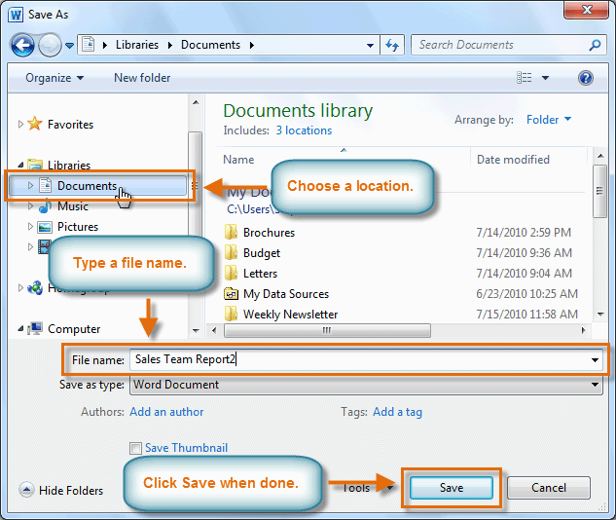

## If you're using Windows 7, you'll usually want to save files to your Documents library, while in other versions of Windows you'll save them to the My Documents folder.

# To use the Save command:

## Click the Save command on the Quick Access toolbar.

## IMG_258

## The document will be saved in its current location with the same file name.

## If you are saving for the first time and select Save, the Save As dialog box will appear.

# AutoRecover

## Word automatically saves your documents to a temporary folder while you're working on them. If you forget to save your changes or if Word crashes, you can recover the auto saved file.

## Open a document that was previously closed without saving.

## In Backstage view, click Info.

## If there are auto saved versions of your file, they will appear under Versions. Click on the file to open it.

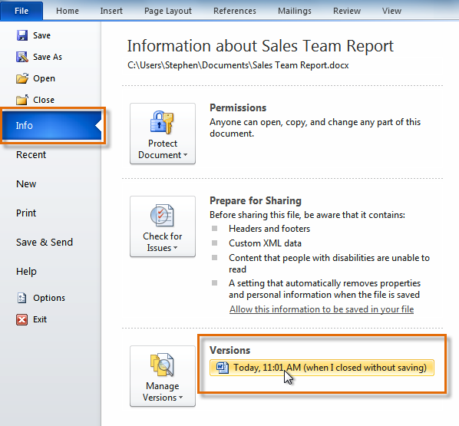

## To save changes, click Restore, then click OK.

## IMG_260

## By default, Word auto saves every 10 minutes. If you are editing a document for less than 10 minutes, Word may not create an auto saved version.

# Other file formats

## You can share your documents with anyone using Word 2010 or 2007 because they use the same file format. However, earlier versions of Word use a different file format, so if you want to share your document with someone using an earlier version of Word you'll need to save it as a Word 97-2003 document.

# To save as a Word 97-2003 document:

## Click the File tab.

## Select Save As.

## In the Save as type drop-down menu, select Word 97-2003 Document.

## IMG_261

## Select the location where you want to save the document.

## Enter a name for the document, then click Save.

# To save as a PDF:

## Click the File tab.

## Select Save As.

## In the Save as type drop-down menu, select PDF.

## IMG_262

## Select the location where you want to save the document.

## Enter a name for the document.

## Click the Save button.